**Technical Documentation**

Framework used is spring mvc where is divided into 3 most important parts

View:mainly used for user interface operations

Controller:backend operations

Model:for the interaction between the view and the controller .

**Technologies used**

* Spring data Jpa
* Thyme leaf
* Spring security
* Spring web
* MySQL driver

**Controller part used for linking the view and the model part according to the users request**

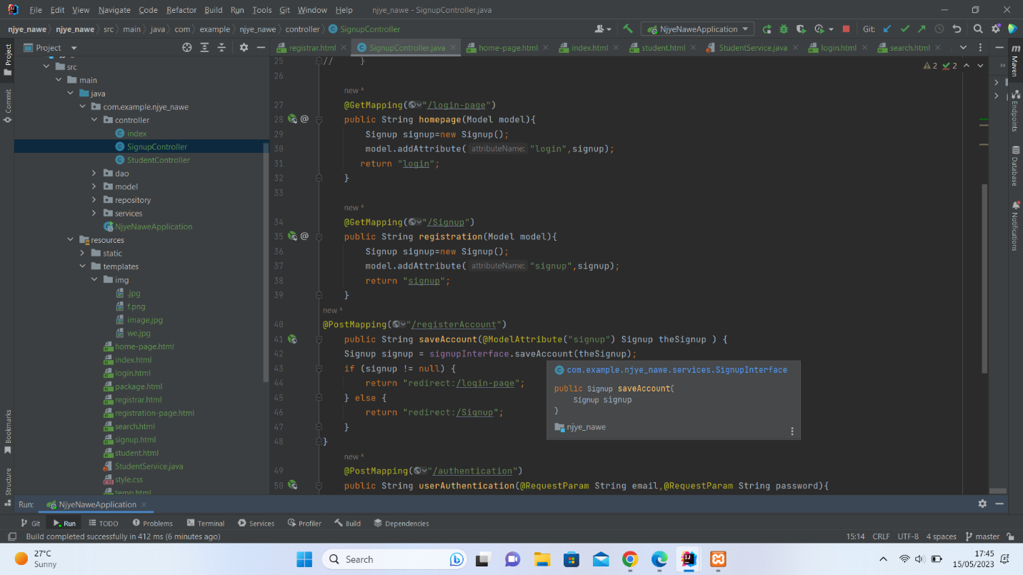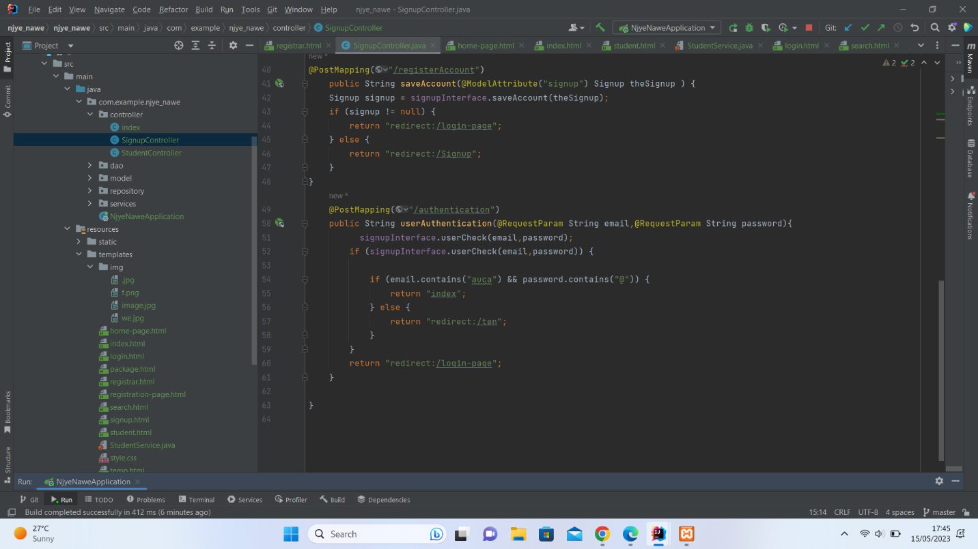

**Model part**

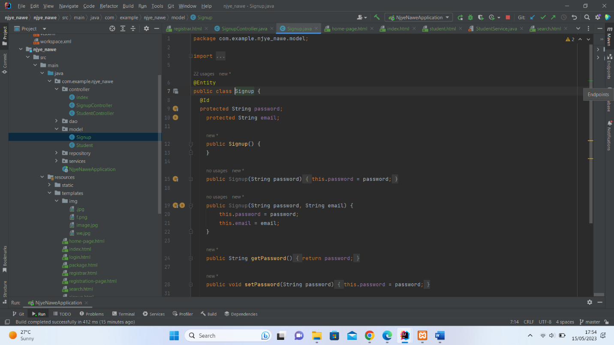

**APPLICATION PROPERTIES**

Where we link our data to the database

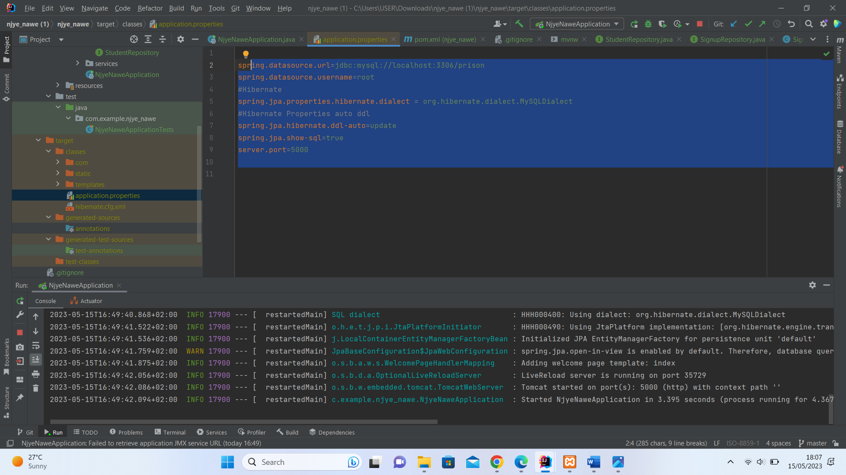

**Service layer**

Where all the CRUD operation take place**.**

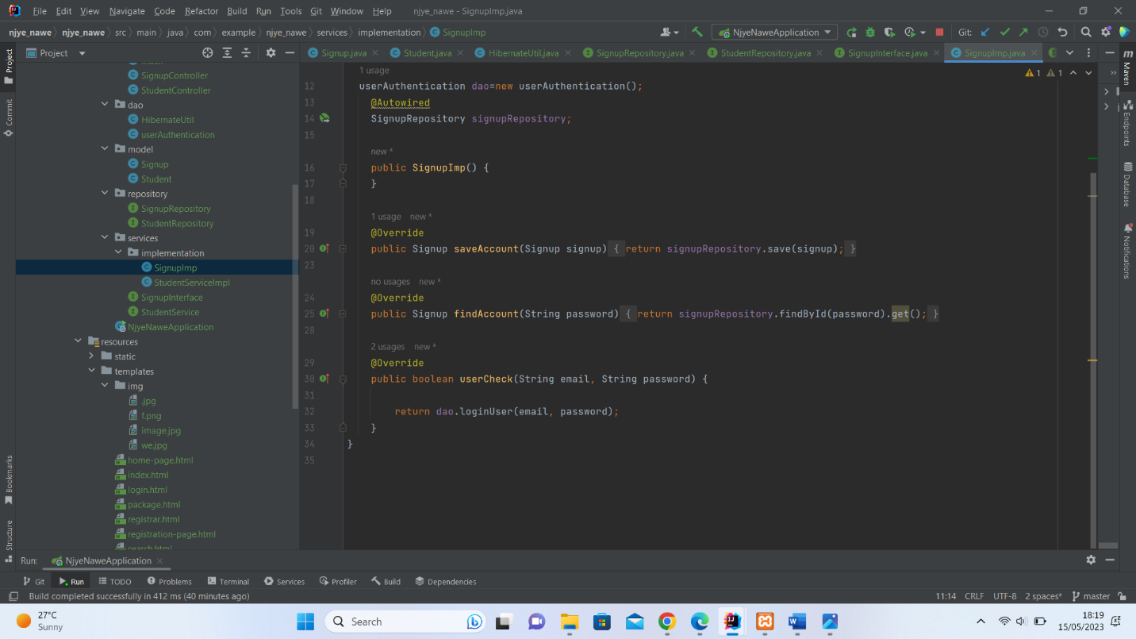

the view layer ,the layer used to interact with the user usually known as the user interface.

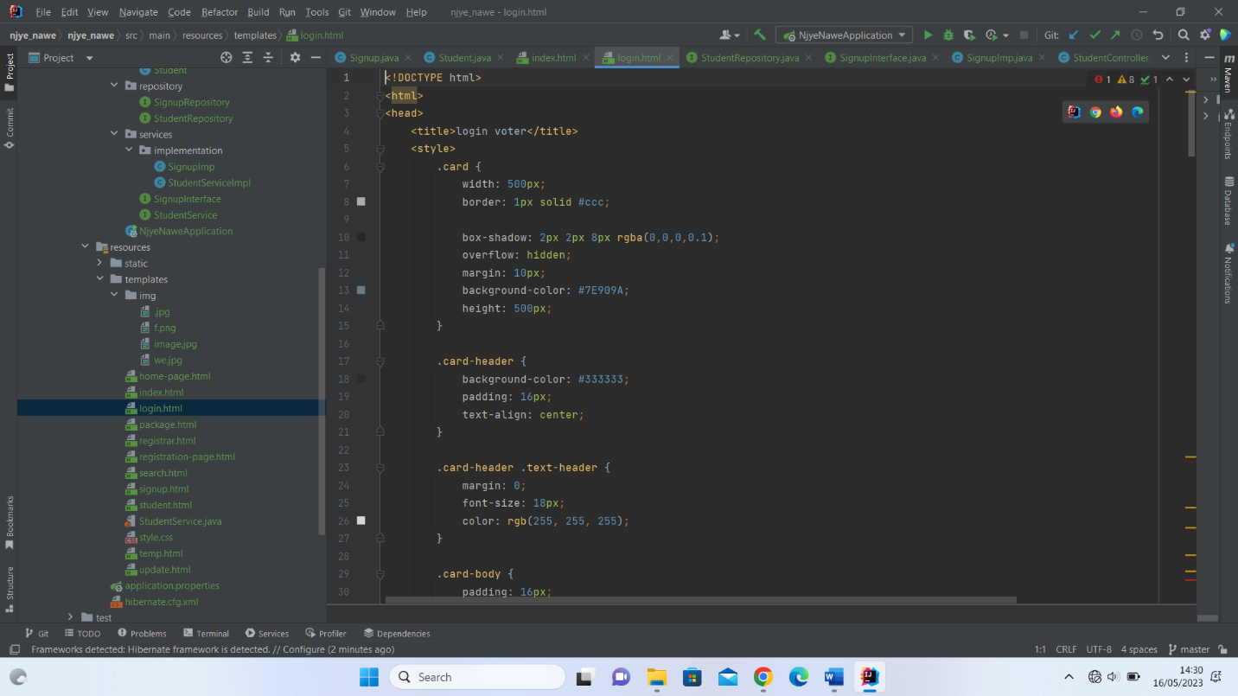

Authentication to check if we have the use in our database

